WEEK-3 JENKINS SETUP
- Create a AWS account and sign in to your account
- In the home page of AWS search for Budgets
- Create budget > select zero spend budget in template > and give budget name as My Zero-Spend Budget>give Email>click on create budget
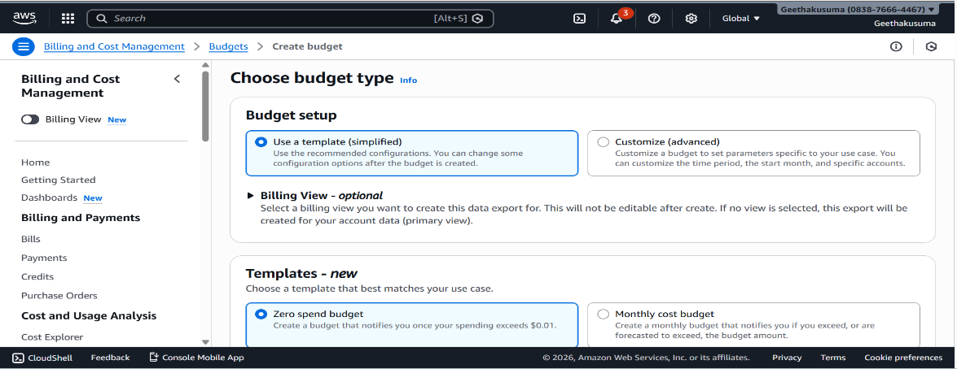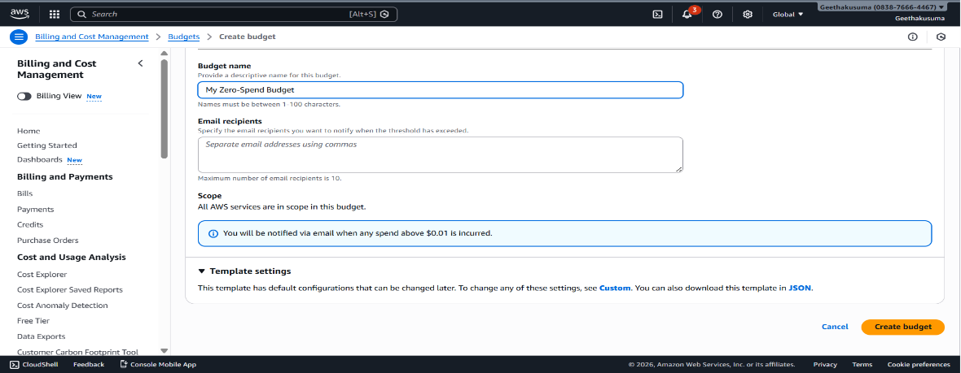

- Search for EC2 > Launch Instance> give name as your wish(Jenkins)
- In Application server Select Ubuntu > Create a NewKey pair
- Number of instances should be 1
- Then Launch instance

Go to security > click on security groups> Edit inbound rule > Add rule>select type as Custom TCP> In port range give 8080 and select 0.0.0.0/0 >Save rule
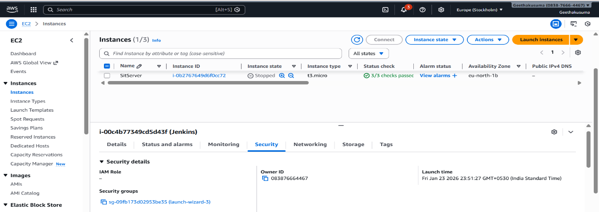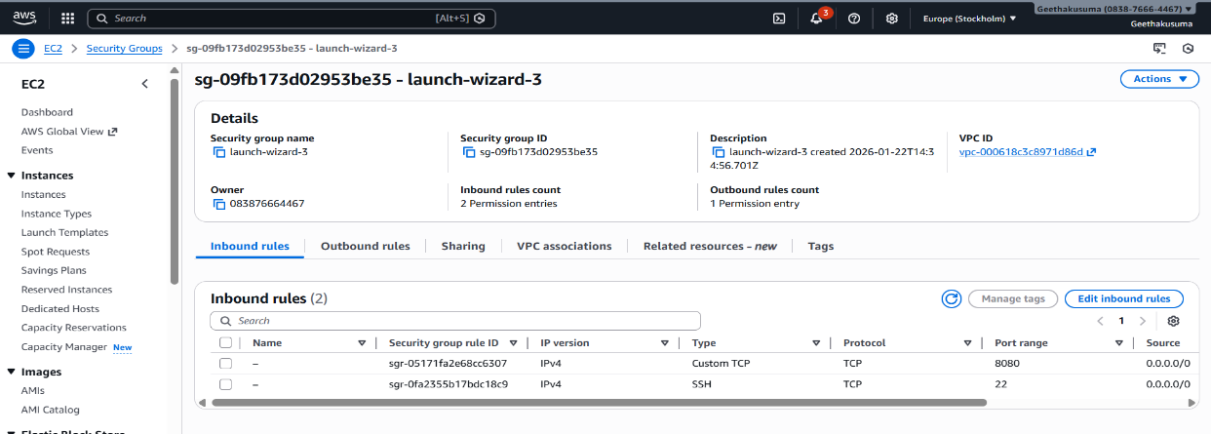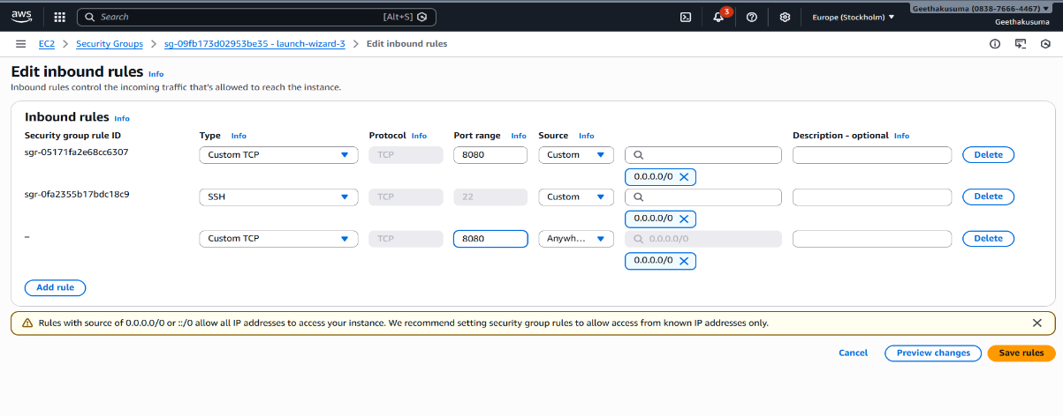
Select the created instance
Click on connect> In EC2 and connect again click on connect

Jenkins Setup:
Search in another tab “Jenkins Documentation”
Installing Jenkins > Linux
Give the commands in the server
- sudo apt update
- sudo apt install fontconfig openjdk-21-jre
- java -version
- sudo wget -O /etc/apt/keyrings/jenkins-keyring.aschttps://pkg.jenkins.io/debian-stable/jenkins.io-2026.key echo "deb [signed-by=/etc/apt/keyrings/jenkins-keyring.asc]" \https://pkg.jenkins.io/debian-stable binary/ | sudo tee \ /etc/apt/sources.list.d/jenkins.list > /dev/null
- sudo apt update
- sudo apt install Jenkins
- sudo systemctl enable Jenkins
- sudo systemctl start Jenkins
- sudo systemctl status jenkins
Now back to instance page copy the Public ip address
Open the browser -->Take the public ip of devserver :8080
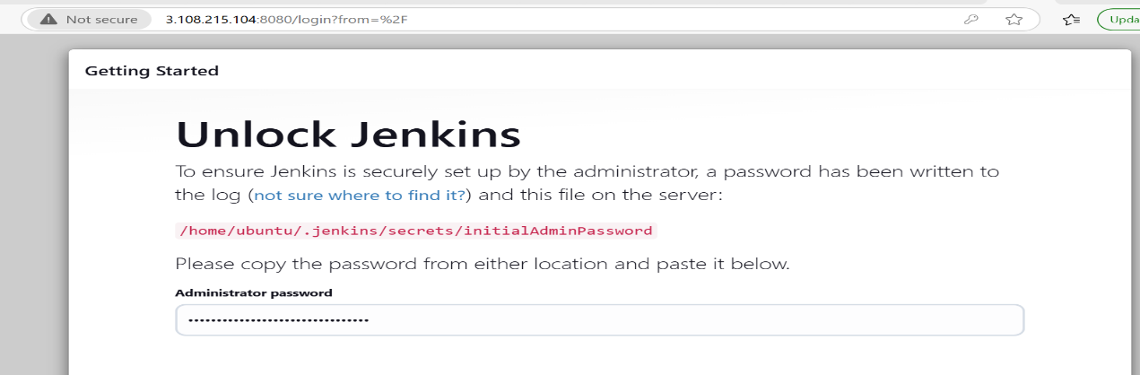
Copy that url go back to Jenkins server and give
- Sudo cat /home/ubuntu/.jenkins/secrets/intialAdminPassword
Copy that password and paste it in the Administrator Password

Click on install suggested plugin

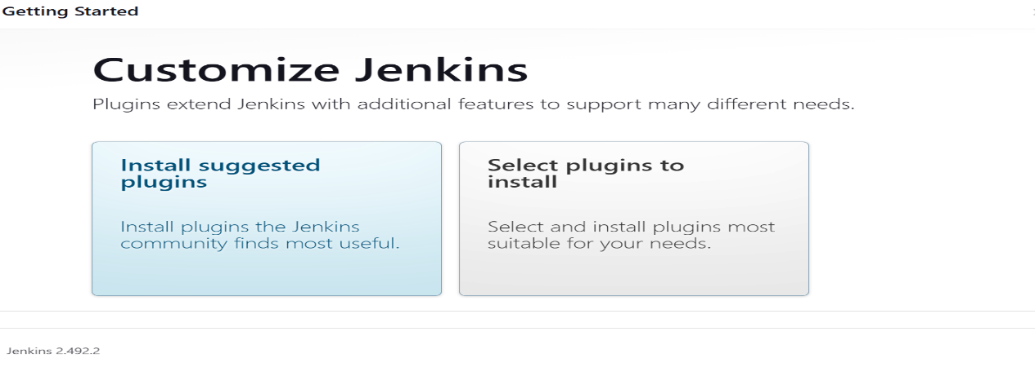

Username=”admin” and Password=”admin” and confirm password=”admin”>Save and Continue

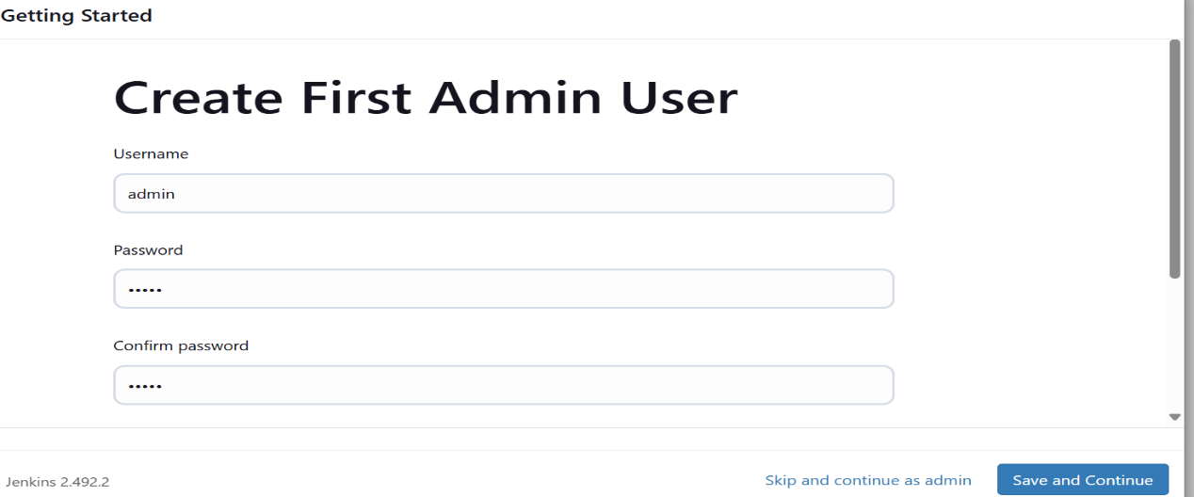

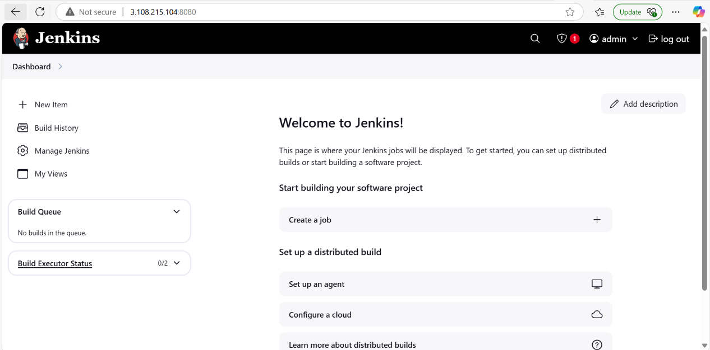

WEEK-5 BUILD WAR FILE IN DEVOPS
In EC2 terminal install git , maven and java
- To install git
sudo apt install git -y
- To install maven
sudo apt install maven -y
- To install java
sudo apt install openjdk-21-jdk -y

Now go to the jenkins dashboard u need to install one plugin (maven integration)

Manage jenkins-->plugins-->available plugins-->maven integration plugin

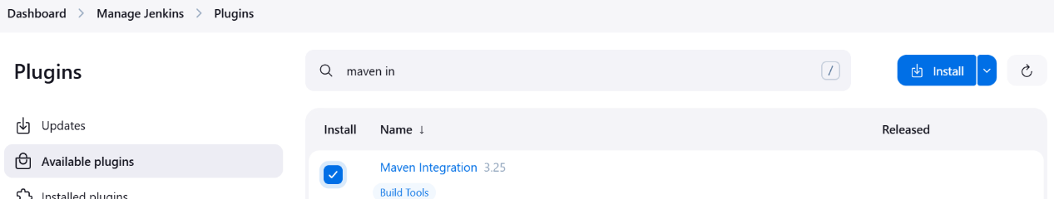

Without this plugin we can’t able to see the maven project

Once installed , click on the restart jenkins

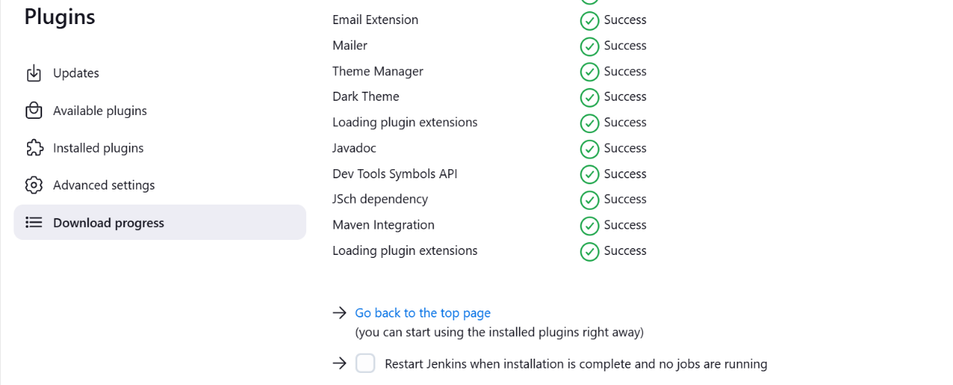

U need to add java and maven paths in the jenkins

Add JDK

Go to jenkins dashboard-->managejenkins-->system>In global properties -check Environmental variables >
Name-JAVA_HOME
Value- /usr/lib/jvm/java-21-openjdk-amd64

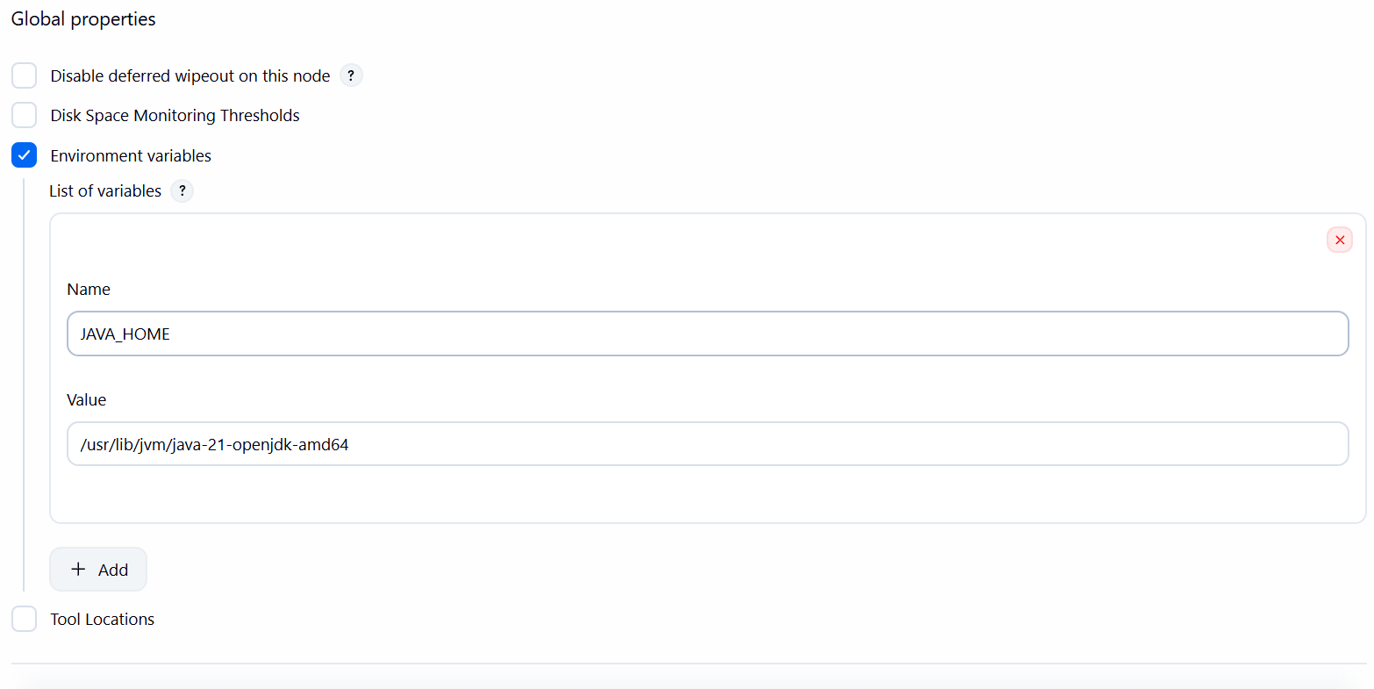
Click apply ans save.

Add maven
Go to jenkins dashboard-->managejenkins-->tools
Give name and check the Install Automatically

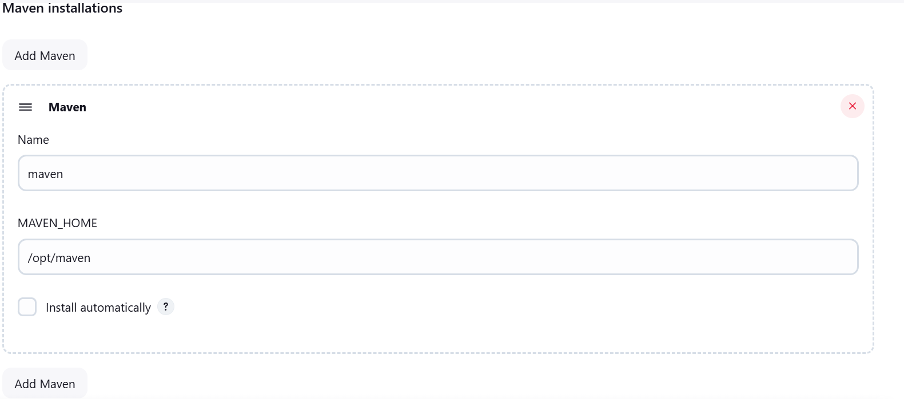

Click on apply and save it

Now we can create job for war file

Dashboard-->newitem-->war(give any name) select maven project click on ok

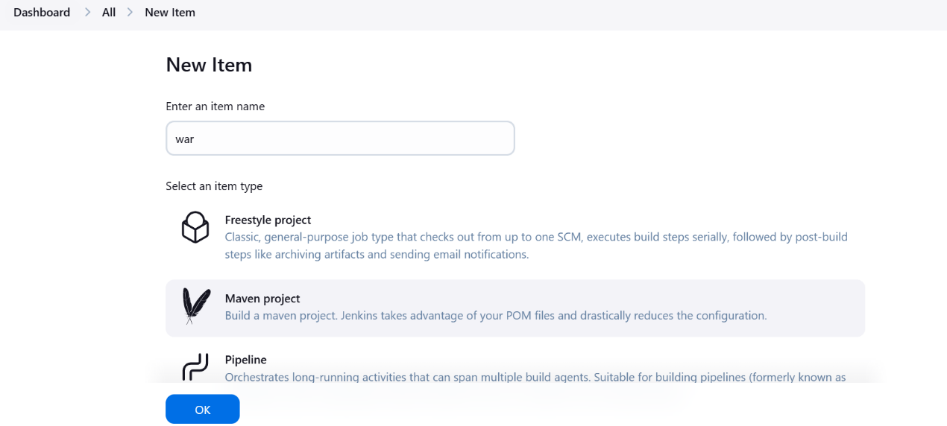

Source code management-->select git--> give the github url project path(open my github account-->go to the repositories
Select the practice repository(week-2 repository where you have the pom.xml file))

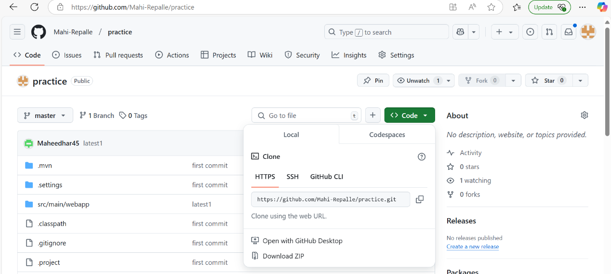

Copy the HTTPS path paste it in the jenkins repository url
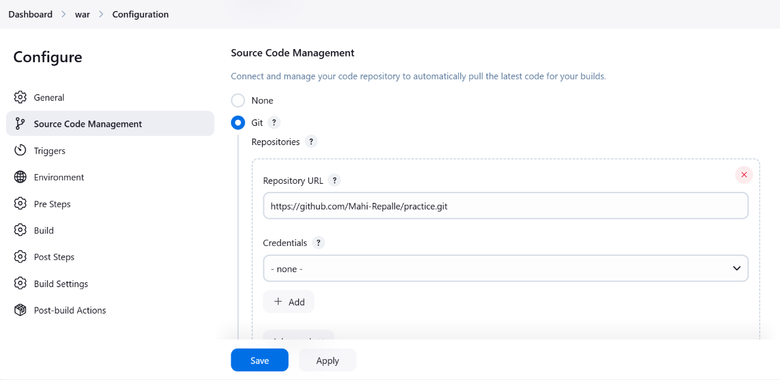

In the buildwar>select Configure>Build >Goals give

clean install package -DskipTests

And click apply and save.
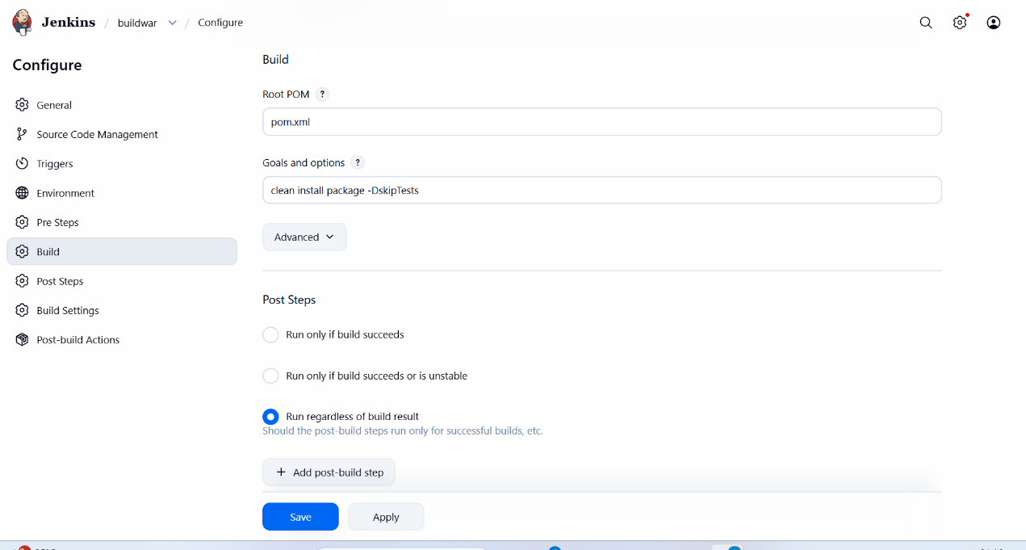

Click on build now

If job execution is taking lot of time
Then
logout the jenkins
Stop the dev instance
Restart the dev instanc
Start the jenkins server
Run the job
Now ur job will be excuted

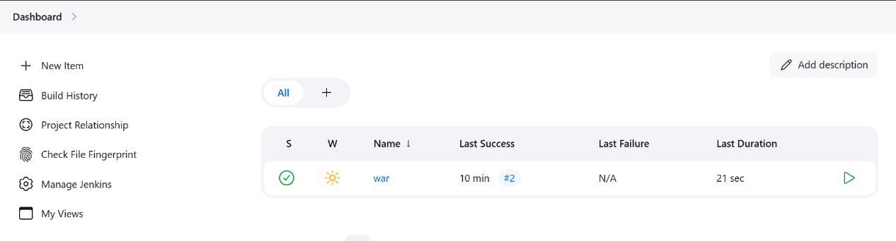

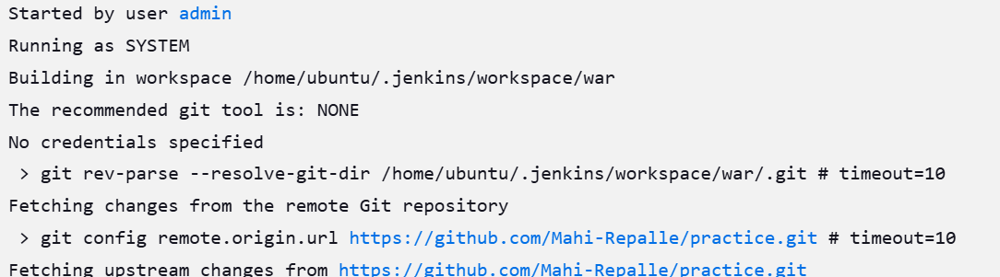

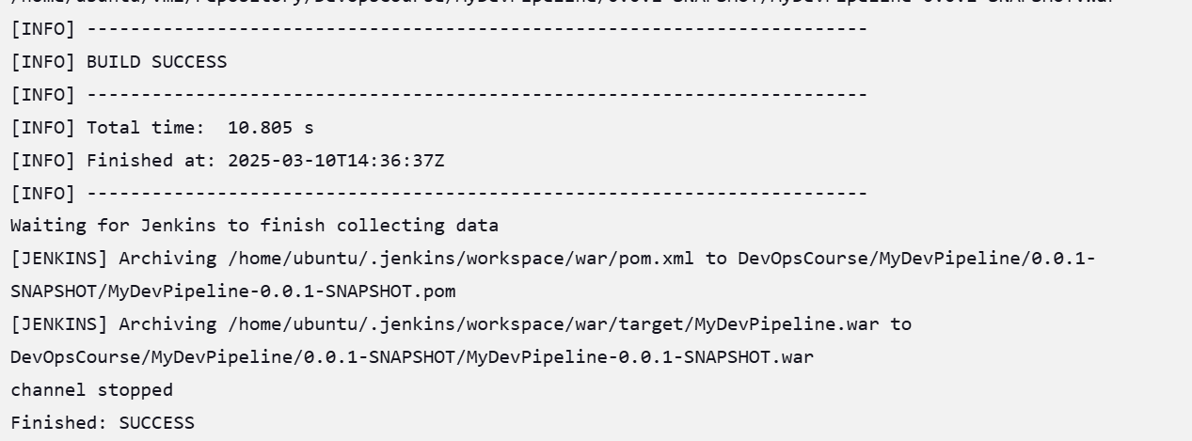

WEEK-10 - Deploy artifcat into sit server

- Launch a new instance with name sit server and use any keypair which is created.
- Connect the instance and start typing the below commands

Update the apt repository
- Sudo apt-get update

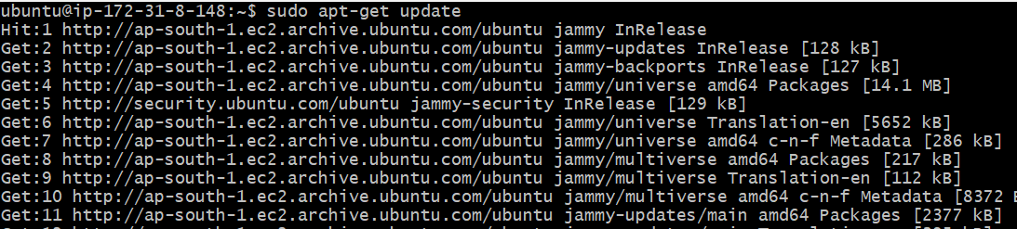
Install tomcat 10
- Sudo apt-get install -y tomcat10

Now install tomcat10 admin as well
- Sudo apt-get install tomcat10-admin

how can we access the tomcat
- Take the public ip of sit server and add 8080(copy paste this command on the browser)

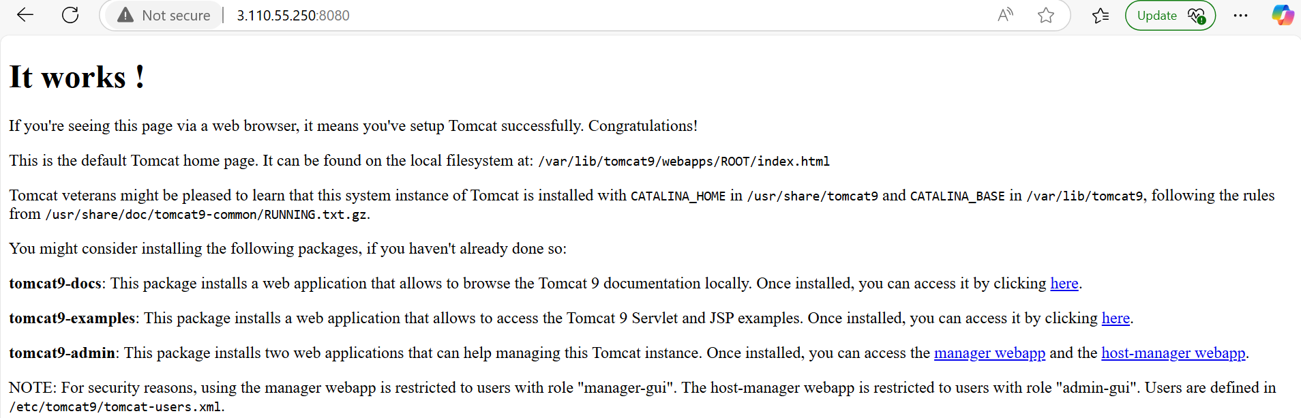

- Cd /etc/tomcat10
- $ll

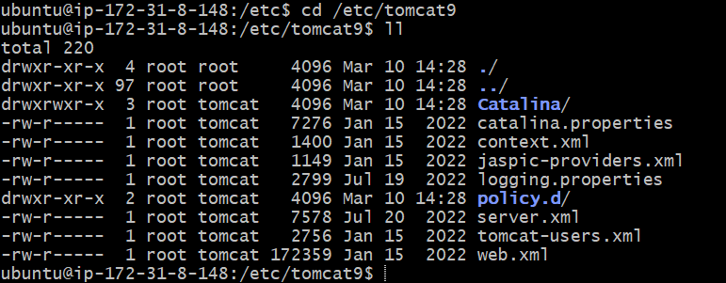
- now we need to add user in the tomcat-users.xml file
- Sudo vim tomcat-users.xml
- Go to the insert mode by using esc+i
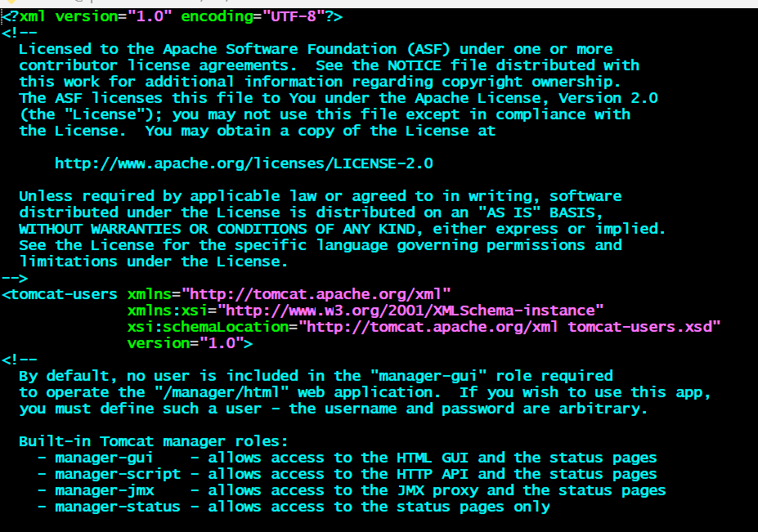

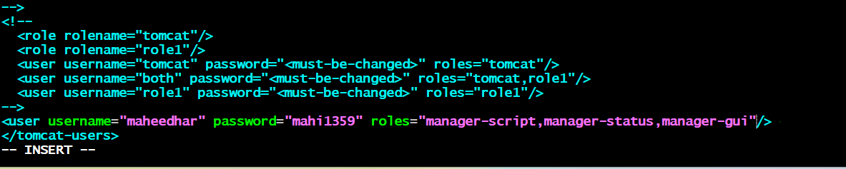

- Type <user username=”tomcat” password=”tomcat123” roles=”manager-script,manager-status,manager-gui”/>

- :wq
- Now restart the tomcat service
- $sudo service tomcat10 restart

- Open Jenkins and add one plugin in the jenkins (deploy to container)
- Manage jenkins-->plugins-->available plugins-->select deploy to container and install it

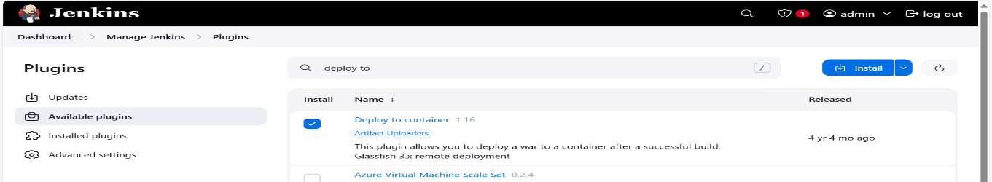

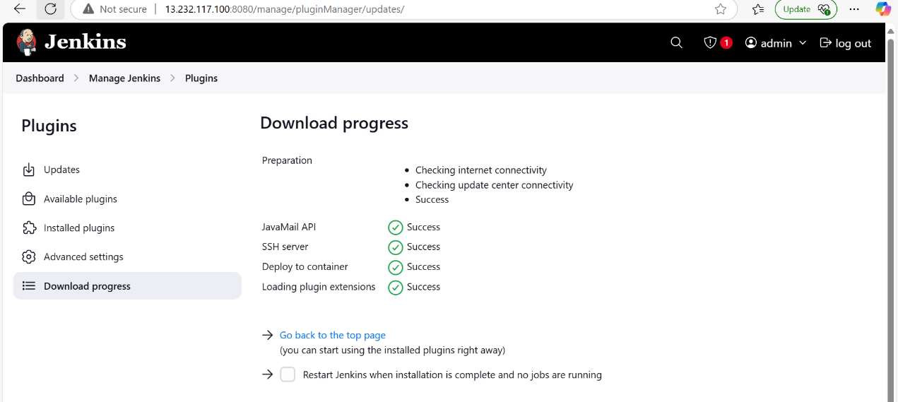

- Now go to the jenkins dashboard
- Select the war job
- Select the configure
- Select the post build action and search deploy war/ear to a container

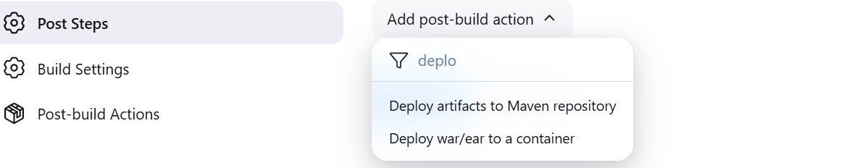

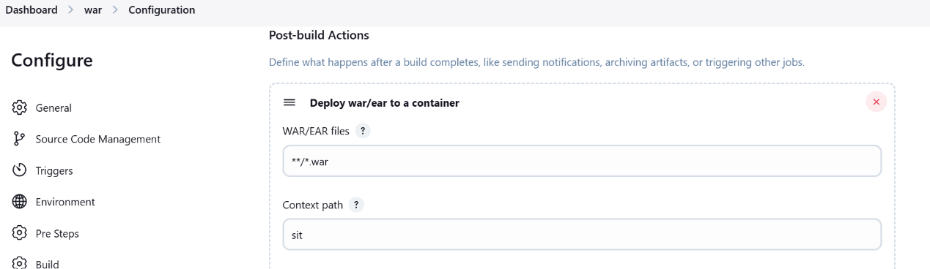

- Add container tomcat 9

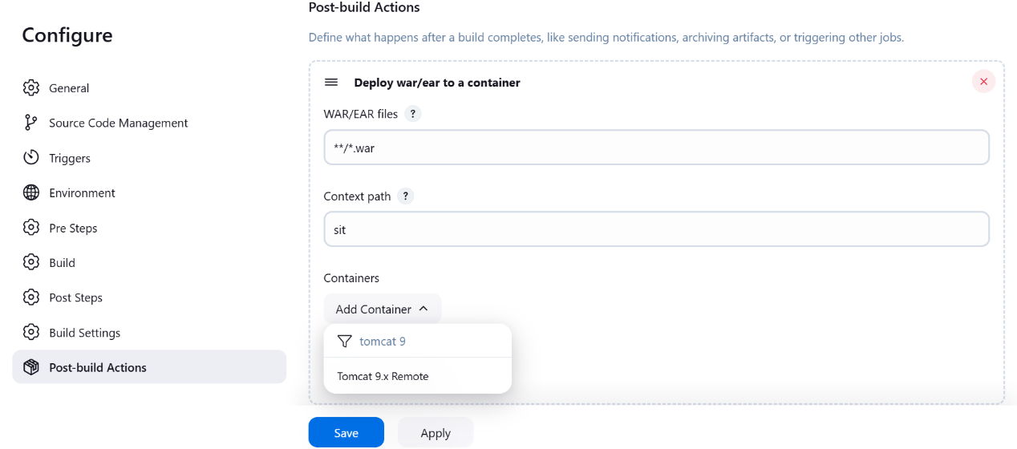

- Add the credentials which are given in tomcat server like Username=tomcat and password=tomcat123

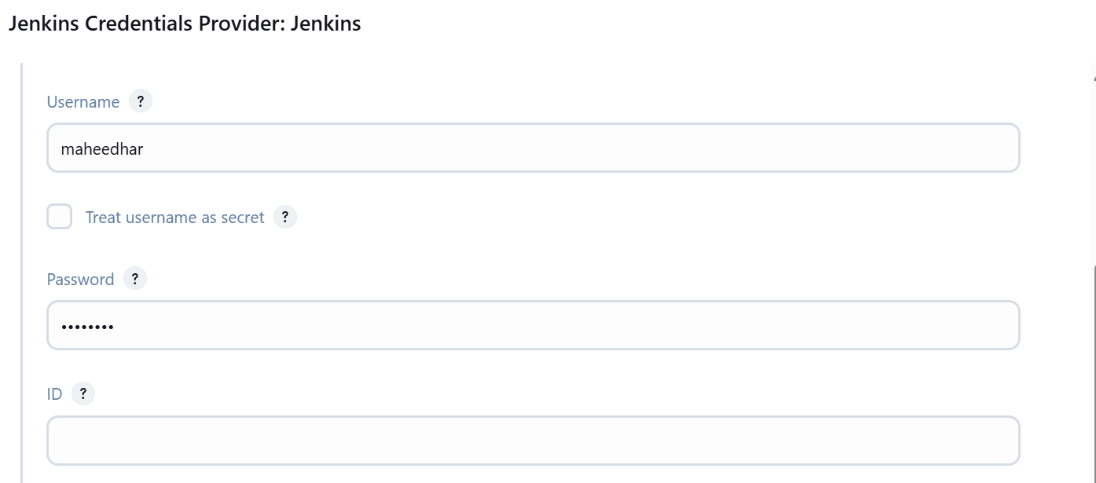

- Select the credentials and choose tomcat\*****> give the tomcat url (sit server path along with 8080 port no)
- Click on apply and save and run the build now

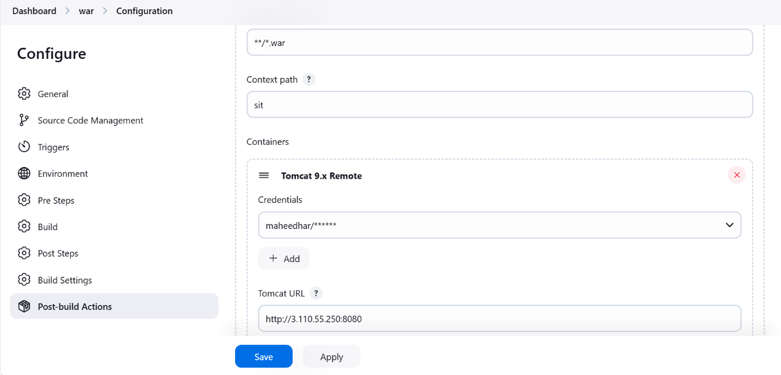

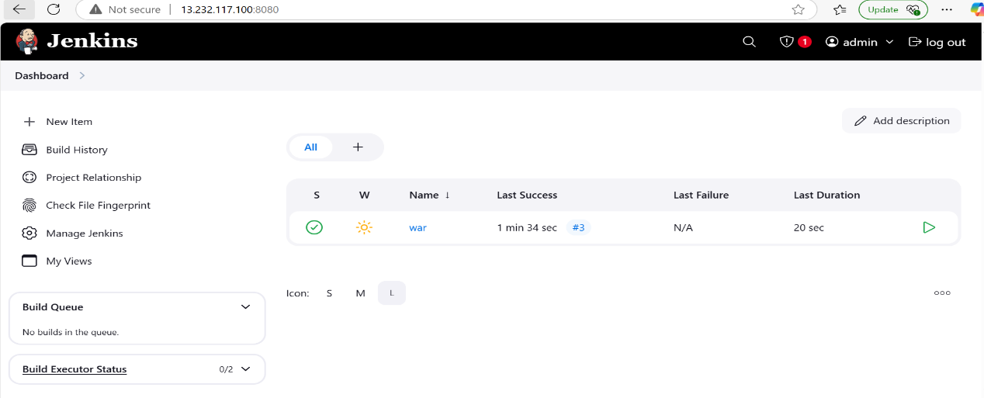

- How can we check the artifact is deployed or not
- Take the sitserver public ip address and port no and give the context path name
Ex: http://3.110.55.250:8080/sit



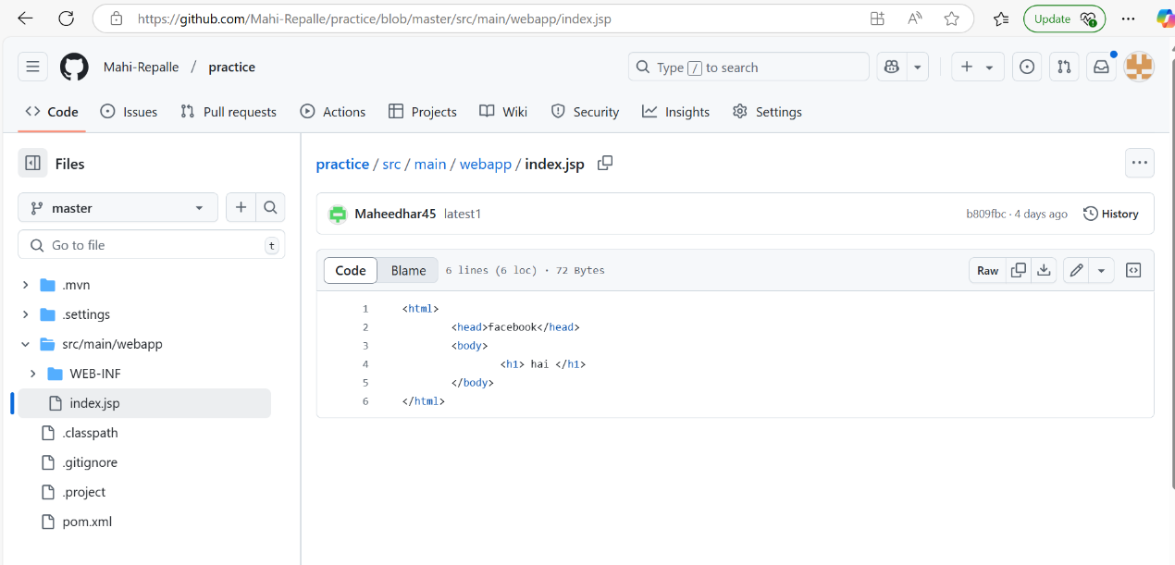

Week-11 AUTOMATION THE JENKINS PIPELINE:

Whenever u made some changes in the source file jenkins job run automatically fetch the code from github to dev server and build the war file and deployed into sit

Admin@DESKTOP-ASGG5M3 MINGW64 /d/CMRIT_24_25/24-25_III_2/DEVOPS/DEVOPS_THEORY_LAB_DOCUMENTS/LAB_EXPERIMENTS/DEVOPS_LAB
$ git clone https://github.com/Mahi-Repalle/practice.git
Cloning into 'practice'...
remote: Enumerating objects: 59, done.
remote: Counting objects: 100% (59/59), done.
remote: Compressing objects: 100% (36/36), done.
remote: Total 59 (delta 9), reused 53 (delta 3), pack-reused 0 (from 0)
Receiving objects: 100% (59/59), 6.13 KiB | 392.00 KiB/s, done.
Resolving deltas: 100% (9/9), done.

Admin@DESKTOP-ASGG5M3 MINGW64 /d/CMRIT_24_25/24-25_III_2/DEVOPS/DEVOPS_THEORY_LAB_DOCUMENTS/LAB_EXPERIMENTS/DEVOPS_LAB
$ ll
total 11008
-rw-r--r-- 1 Admin 197121 1555602 Feb 1 20:22 Ansible_Setup.docx
-rw-r--r-- 1 Admin 197121 434977 Feb 20 19:38 'Deploy to Server.docx'
-rw-r--r-- 1 Admin 197121 850944 Jan 8 18:19 EXP1-STEPS.doc
-rw-r--r-- 1 Admin 197121 1886107 Jan 27 19:00 Experiment-2.pdf
-rw-r--r-- 1 Admin 197121 1279778 Jan 21 07:47 Jenkins_setup_on_AWS.docx
-rw-r--r-- 1 Admin 197121 1748522 Feb 15 06:44 War_With_Maven.doc
-rw-r--r-- 1 Admin 197121 314368 Feb 21 18:49 automation.doc
-rw-r--r-- 1 Admin 197121 1725354 Feb 19 20:24 docker.docx
drwxr-xr-x 1 Admin 197121 0 Mar 10 20:35 practice/
-rw-r--r-- 1 Admin 197121 1451061 Jan 26 20:35 'war file.docx'
-rw-r--r-- 1 Admin 197121 162 Feb 19 07:08 '~$docker.docx'
-rw-r--r-- 1 Admin 197121 162 Feb 20 06:31 '~$ploy to Server.docx'
-rw-r--r-- 1 Admin 197121 162 Feb 20 11:38 '~$r_With_Maven.doc'
-rw-r--r-- 1 Admin 197121 162 Feb 19 20:34 '~$sible_Setup.docx'

Admin@DESKTOP-ASGG5M3 MINGW64 /d/CMRIT_24_25/24-25_III_2/DEVOPS/DEVOPS_THEORY_LAB_DOCUMENTS/LAB_EXPERIMENTS/DEVOPS_LAB
$ cd practice

Admin@DESKTOP-ASGG5M3 MINGW64 /d/CMRIT_24_25/24-25_III_2/DEVOPS/DEVOPS_THEORY_LAB_DOCUMENTS/LAB_EXPERIMENTS/DEVOPS_LAB/practice (master)
$ ll
total 4
-rw-r--r-- 1 Admin 197121 1896 Mar 10 20:35 pom.xml
drwxr-xr-x 1 Admin 197121 0 Mar 10 20:35 src/

Admin@DESKTOP-ASGG5M3 MINGW64 /d/CMRIT_24_25/24-25_III_2/DEVOPS/DEVOPS_THEORY_LAB_DOCUMENTS/LAB_EXPERIMENTS/DEVOPS_LAB/practice (master)
$ cd src

Admin@DESKTOP-ASGG5M3 MINGW64 /d/CMRIT_24_25/24-25_III_2/DEVOPS/DEVOPS_THEORY_LAB_DOCUMENTS/LAB_EXPERIMENTS/DEVOPS_LAB/practice/src (master)
$ ll
total 0
drwxr-xr-x 1 Admin 197121 0 Mar 10 20:35 main/

Admin@DESKTOP-ASGG5M3 MINGW64 /d/CMRIT_24_25/24-25_III_2/DEVOPS/DEVOPS_THEORY_LAB_DOCUMENTS/LAB_EXPERIMENTS/DEVOPS_LAB/practice/src (master)
$ cd main

Admin@DESKTOP-ASGG5M3 MINGW64 /d/CMRIT_24_25/24-25_III_2/DEVOPS/DEVOPS_THEORY_LAB_DOCUMENTS/LAB_EXPERIMENTS/DEVOPS_LAB/practice/src/main (master)
$ ll
total 0
drwxr-xr-x 1 Admin 197121 0 Mar 10 20:35 webapp/

Admin@DESKTOP-ASGG5M3 MINGW64 /d/CMRIT_24_25/24-25_III_2/DEVOPS/DEVOPS_THEORY_LAB_DOCUMENTS/LAB_EXPERIMENTS/DEVOPS_LAB/practice/src/main (master)
$ cd webapp

Admin@DESKTOP-ASGG5M3 MINGW64 /d/CMRIT_24_25/24-25_III_2/DEVOPS/DEVOPS_THEORY_LAB_DOCUMENTS/LAB_EXPERIMENTS/DEVOPS_LAB/practice/src/main/webapp (master)
$ ll
total 1
drwxr-xr-x 1 Admin 197121 0 Mar 10 20:35 WEB-INF/
-rw-r--r-- 1 Admin 197121 78 Mar 10 20:35 index.jsp

Admin@DESKTOP-ASGG5M3 MINGW64 /d/CMRIT_24_25/24-25_III_2/DEVOPS/DEVOPS_THEORY_LAB_DOCUMENTS/LAB_EXPERIMENTS/DEVOPS_LAB/practice/src/main/webapp (master)
$ vim index.jsp

Admin@DESKTOP-ASGG5M3 MINGW64 /d/CMRIT_24_25/24-25_III_2/DEVOPS/DEVOPS_THEORY_LAB_DOCUMENTS/LAB_EXPERIMENTS/DEVOPS_LAB/practice/src/main/webapp (master)
$ git status
On branch master
Your branch is up to date with 'origin/master'.

Changes not staged for commit:
(use "git add <file>..." to update what will be committed)
(use "git restore <file>..." to discard changes in working directory)
modified: index.jsp

no changes added to commit (use "git add" and/or "git commit -a")

Admin@DESKTOP-ASGG5M3 MINGW64 /d/CMRIT_24_25/24-25_III_2/DEVOPS/DEVOPS_THEORY_LAB_DOCUMENTS/LAB_EXPERIMENTS/DEVOPS_LAB/practice/src/main/webapp (master)
$ git add .

Admin@DESKTOP-ASGG5M3 MINGW64 /d/CMRIT_24_25/24-25_III_2/DEVOPS/DEVOPS_THEORY_LAB_DOCUMENTS/LAB_EXPERIMENTS/DEVOPS_LAB/practice/src/main/webapp (master)
$ git status
On branch master
Your branch is up to date with 'origin/master'.

Changes to be committed:
(use "git restore --staged <file>..." to unstage)
modified: index.jsp

Admin@DESKTOP-ASGG5M3 MINGW64 /d/CMRIT_24_25/24-25_III_2/DEVOPS/DEVOPS_THEORY_LAB_DOCUMENTS/LAB_EXPERIMENTS/DEVOPS_LAB/practice/src/main/webapp (master)
$ git commit -m "ab"
[master 74b2935] ab
1 file changed, 1 insertion(+), 1 deletion(-)

Admin@DESKTOP-ASGG5M3 MINGW64 /d/CMRIT_24_25/24-25_III_2/DEVOPS/DEVOPS_THEORY_LAB_DOCUMENTS/LAB_EXPERIMENTS/DEVOPS_LAB/practice/src/main/webapp (master)
$ git push origin master
Enumerating objects: 11, done.
Counting objects: 100% (11/11), done.
Delta compression using up to 8 threads
Compressing objects: 100% (4/4), done.
Writing objects: 100% (6/6), 469 bytes | 469.00 KiB/s, done.
Total 6 (delta 1), reused 0 (delta 0), pack-reused 0 (from 0)
remote: Resolving deltas: 100% (1/1), completed with 1 local object.
To https://github.com/Mahi-Repalle/practice.git
b809fbc..74b2935 master -> master

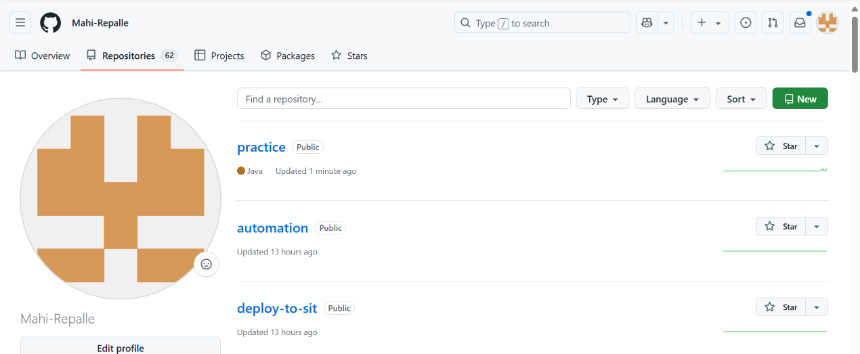

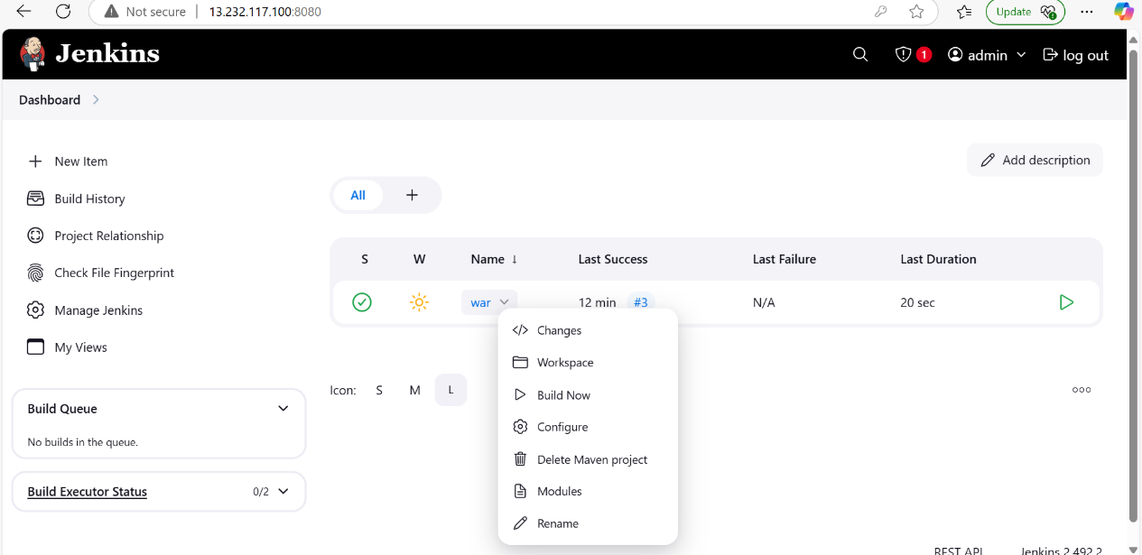

Triggers u can select the poll scm and give the crontab values

* * * * *

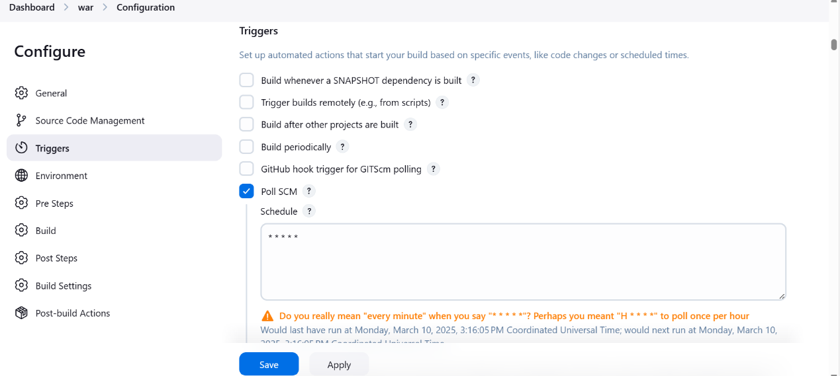

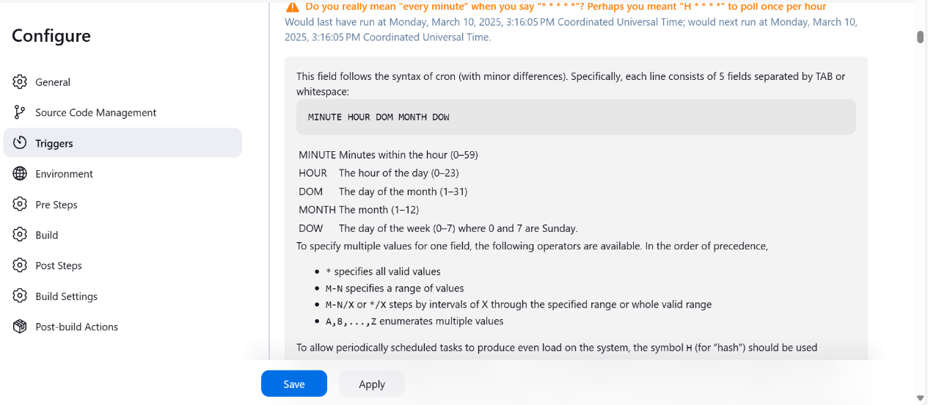

Click on apply and save the job

Don’t run the build now

Jenkins automatically trigger the job

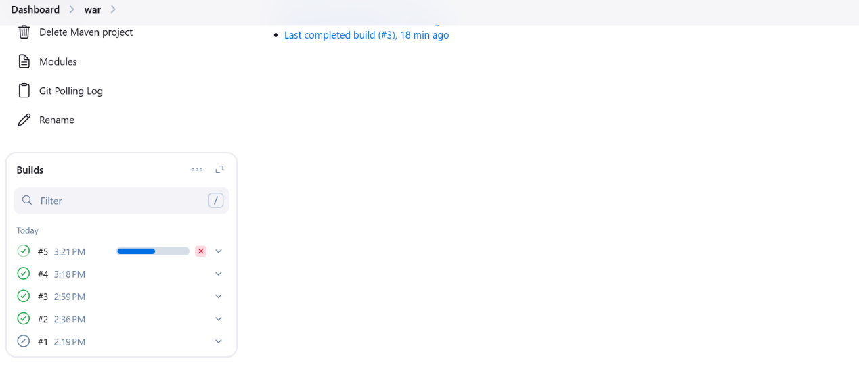

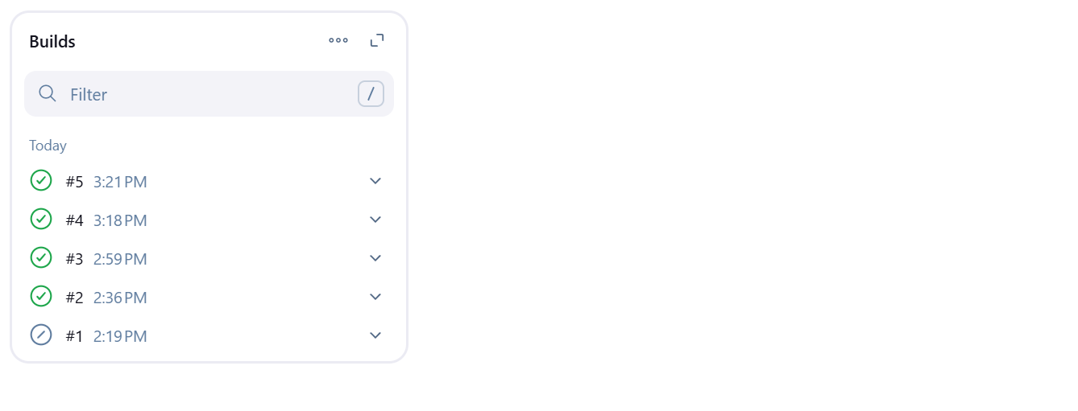

Now refresh the sit server latest code changes are reflected in the sit

